2. Literature review
There are many tools that allow individuals, teams, and organizations to perform their essential day-to-day operations faster and more efficiently. They can improve the productivity and efficiency simply by improving concentration, assisting to prioritize schedules and work to deadlines. They assist to manage the workflow and time expenses with the help of task management and time management. Some tools are focused on improving focus and discipline (Pomodoro Techniques), some on scheduling tasks and setting ambitious new personal goals. (To-do Lists), some on tracking the time spend and achievements gained on certain task (Session Tracker), and some by keeping records of things that are to be learned (Study Planner). There are many apps and tools designed to improve the productivity based on above mentioned techniques as Forest, Microsoft To Do, Todoist, Tide etc. Some of them are briefly described below:
2.1 Forest
This app is designed on the Pomodoro technique to help you focus on the task. This app takes on a creative approach to help you stay focused. Whenever you want to start a study session, you plant a tree in your in-app “forest”. As you work, the tree will begin to grow, but if you pick up your phone and leave the app, your tree dies! You can collect and add more trees to your forest the more you focus. The company even plants real trees in dozens of countries! It’s a win-win situation for you and the Earth.
2.2 Microsoft To Do
Microsoft To Do is a cloud-based task management application. It allows users to manage their tasks from a smartphone, tablet and computer. Using Microsoft To Do, you can start each day with a clean outlook on the tasks you need to do, across all your devices. Being a student involves balancing assignments, clubs, errands, and everyday tasks, so this app can help you get each task finished. If a task requires multiple steps, you can add subtasks under each one! When you’re done, enjoy the satisfaction of checking it off.
2.3 Tide
Tide is an app that offers you the best focus timer with natural white noise. It is the perfect fusion of productivity, wellness, and beautiful design. The app allows you to set up personalized Pomodoro-focus sessions, with a wide variety of nature sounds, white noise, and calm music. If you leave the app, you’ll “fail” the focus section! The app also features sleep, nap, meditation, and beautiful daily quotes to keep you motivated.
These are few examples among the large number of tools readily available in the market focused on the improvement of productivity. However there is lack of platform which brings the features of these great apps together for better and effective implementation of all these techniques. So we came up with the idea of our very own tool, “Productivity Companion” which is the integration of various features from various great productivity apps in a single platform. This tool can be used by professionals, students, teachers and any individuals or group to boost their productivity and efficiency. Person using this tool will surely notice a drastic improvement of their workflow and time management.

3. PROPOSED SYSTEM ARCHITECTURE
The project ‘Productivity Companion’ features numerous time management methods and organizing techniques centered tabs which is in itself an app. The main application comprises of four sub-app namely Pomo Timer, Session Tracker, To-do list and Study planner. All these apps commonly includes various UI components to make the entire app interactive.

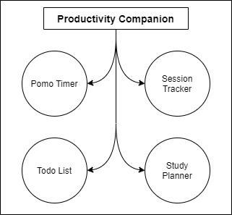
Figure 3.1: Basic overview
3.1 Individual App System Architecture
3.1.1 Pomo Timer
The prominent Promodoro Technique is incorporated via a simple timer with the added feature of rewarding the user for every pomodoro (interval). An initial timer of 25 minutes is allowed with higher limit being 120 minutes i.e. 2 hours. A knob that act as a handle sliding in circular path responsive to the user mouse movement is used to set the interval. Points for every pomodoro based on the length of interval is rewarded. An additional feature to this app might be the optional legal free copy-righted lo-fi song to play during the pomodoro.
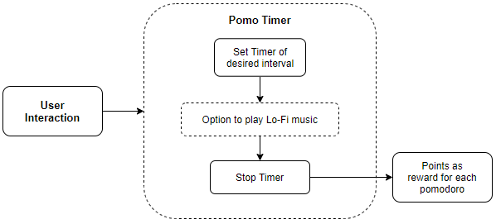
Figure 3.2: Pomo Timer Architecture
3.1.2 Session Tracker
Session tracking app that keeps track of time stamps and duration. User is provided with the option to manually type and create new session / project in the initial window. The created session tab consist of relevant parameters that best describe the session itself. This session tab opens in a new interactive session window which features a stop-watch that keeps track of the whole time taken by the project / task. On exit the model from the related database is updated.
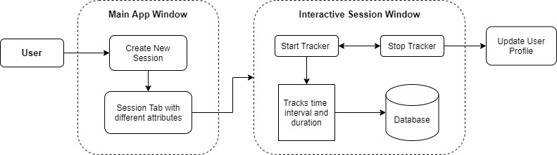
Figure 3.3: Session Tracker Architecture
3.1.3 To-do list
Ordered top-to-down listing of the task. Task added are represented in a div like element which includes editing / updating, remove option. Completion of any task is denoted by a strike through the task. Using CRUD on the related model in the local database the task is manipulated and stored.
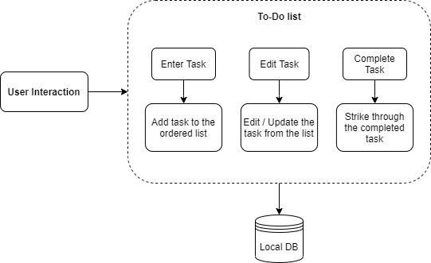
Figure 3.4: To-do List Architecture
3.1.4 Study Planner
The system architecture of ‘Study Planner’ is the amalgamation of both ‘Session planner’ and ‘To-do list’. It is the extended form of to-do list which features separate section for every topic as plan sheet. The plan sheet tab displays the required details related to it. Each plan sheet expands into a separate Plan Sheet window where adding, editing / updating of the task is accomplished. Completion of any task in the list is designated by a strike through. Using CRUD on the related model of the database, the information for all the plan sheet is handled and stored.
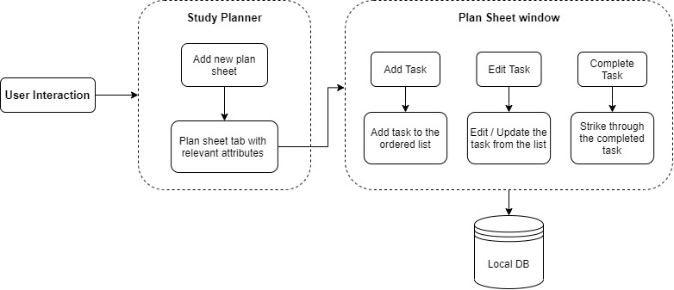
Figure 3.5: Study Planner Architecture
3.2 Data Flow Diagram
The main window displays four different sub-app that the user choose to navigate. The first app being the ‘Pomo Timer’. The only data flow in the Pomo Timer is the points that the user collects for every Pomodoro (interval) which is stored as a reward point.
The second tab features ‘Session Tracker’. The data handling in this app will require a simple model that keeps track of the time stamps and the duration along the date. The stored session data is loaded from the stored database. Any modification to the existing session will be updated to the corresponding session data.
The third tab ‘To-do List’ grabs any previous task data from the database and then loads it in the display view. Any modification to the list will be updated to the corresponding table as the tab is closed.
The final tab ‘Study Planner’ loads the plan sheet tabs if any into the initial display window. Each tab is a planner sheet that loads any previous task list in a separate interactive display window. Any modification to the planner sheet will be updated to the corresponding table as the sheet is closed.
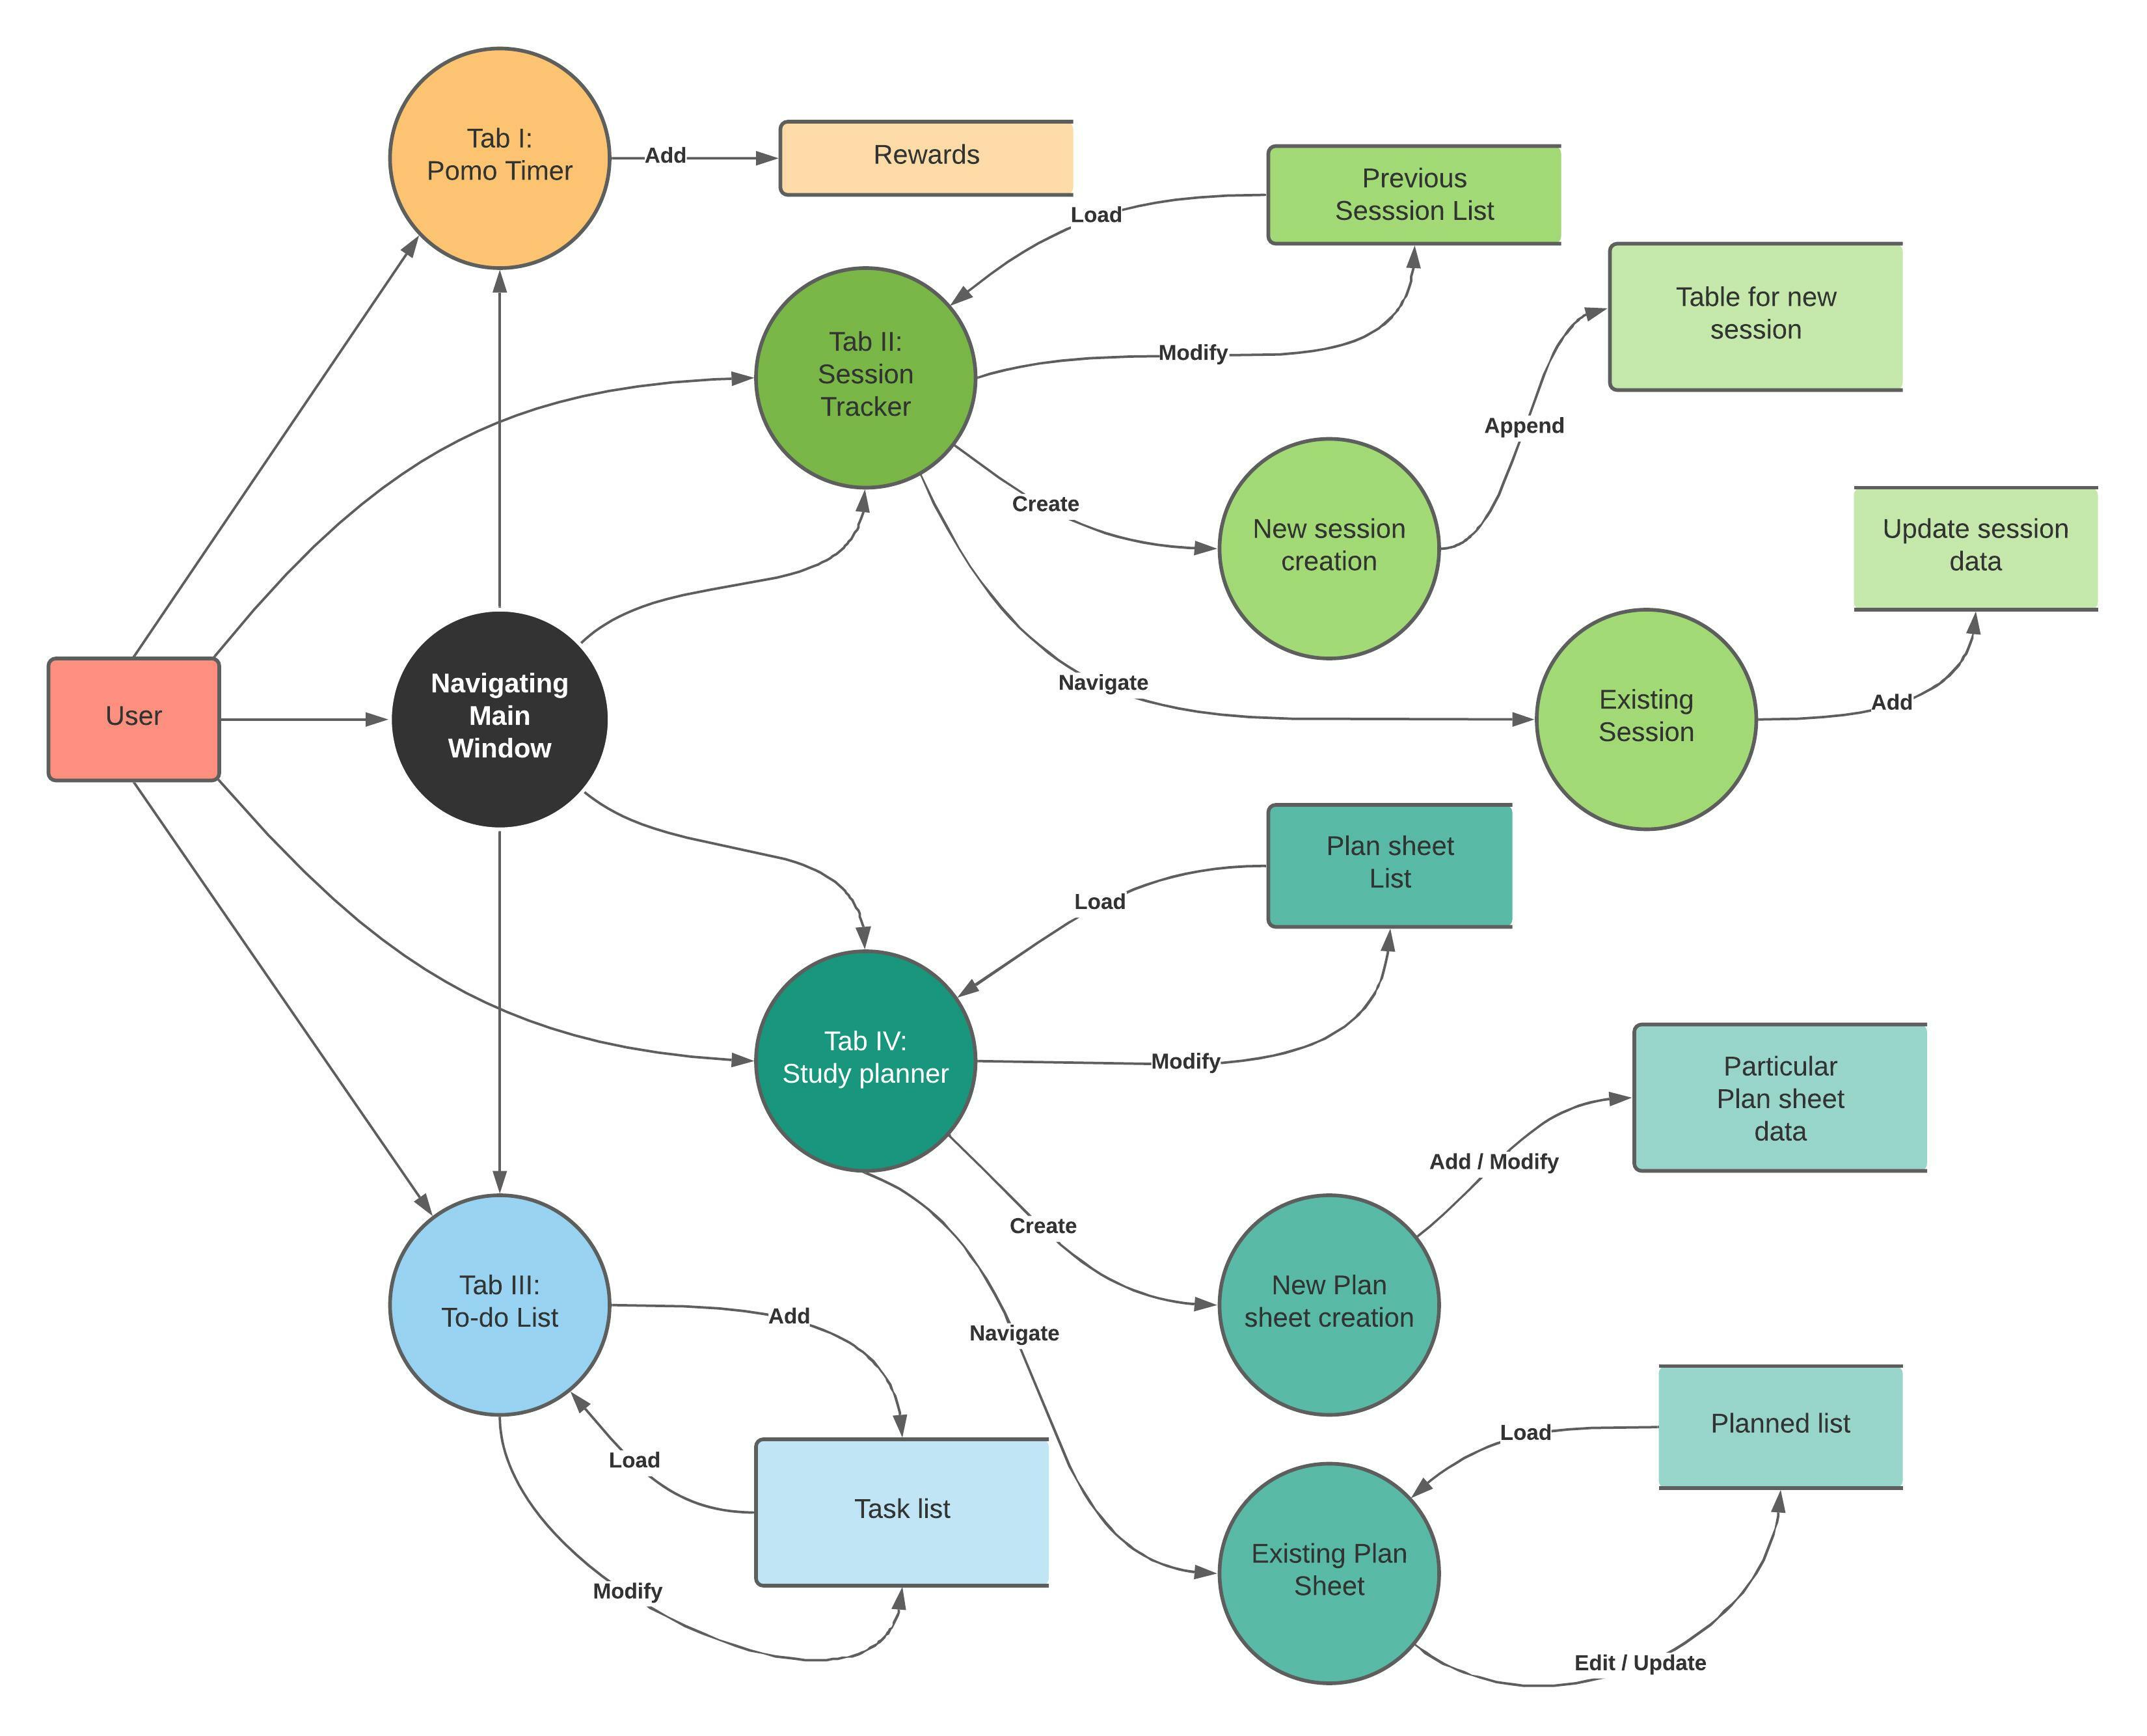
Figure 3.6: Data Flow Diagram of the Proposed System
3.3 Tools and Environment
3.3.1 IDE Used
Visual Studio 2019: Visual studio is used in our project for User Interface Development using some GUI library.
Embarcadero Dev-C++ 6.9: It is used in our project for basic theory testing.
3.3.2 Programming Language and Library Used
C++: C++11 is used in our project.
SFML: Simple and Fast Multimedia Library (SFML) is used as GUI library for our project.

